### CHANDIGARH COLLEGE OF ENGINEERING AND TECHNOLOGY

**(DEGREE WING)**

Government Institute under Chandigarh (UT) Administration, Affiliated to Panjab University, Chandigarh

Sector-26, Chandigarh. PIN-160019

#### 2024

## Bachelor of Engineering

**IN COMPUTER SCIENCE AND ENGINEERING**

**3rd Sem**



**DBS PRACTICAL - 3**

**Submitted by Submitted To**

## Sanatan Sharma Dr. Dheerendra Singh

**(Roll no:CO23355) (Professor)**

Aim:

Modification of the Database: Deletion of tuples from a given relation,

Updating of values in some tuples in a given relation on WAMP/ LAMP

/XAMPP /SQL server.

PROCEDURE:

**1) Navigate to the Desired Table:**

* In the database management tool, select the table from which you want to delete tuples.

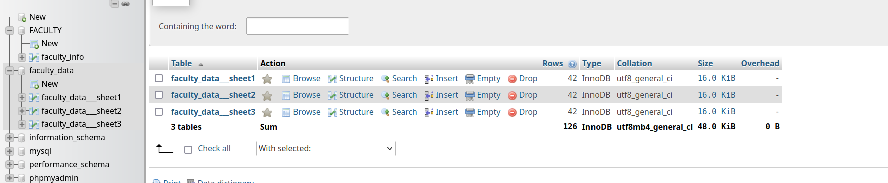2) **Write and Execute SQL DELETE Queries:**

* Enter the SQL DELETE queries in the SQL command window and execute them.

Format DELETE FROM “table_name” WHERE “CONDITON”